Problem
The Meteor Mic LED is either dim red, or red+yellow. Blue LED no longer lights, even if mute button is pressed:
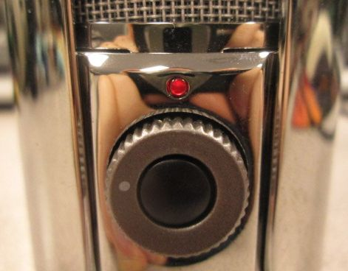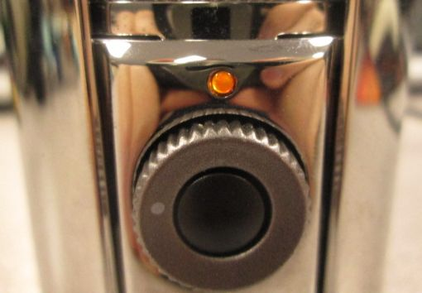
It may be recognized by the computer as “USB Advanced Audio Device”:
This is caused by corruption of the firmware in the mic, which then reverts to default settings, as it if had no firmware. It can be fixed by re-burning the firmware to the mic:

Instructions
- Download and extract Meteor Mic firmware repair.zip:
- Connect the Meteor Mic to the computer and disconnect any other USB audio devices.
- Run the Config6400.exe file:
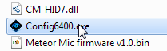
- Fill in the boxes for VID 0d8c and PID 016c at the bottom of the Configuration tool (not the ones at the top):
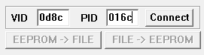
- Press the Connect button. If it does not connect, make sure the mic is plugged in and the VID and PID are correct.
- It may say “EEPROM empty”; press Ok.
- When the FILE -> EEPROM button becomes available, press it:
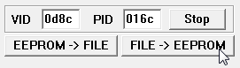
- Choose the Meteor Mic firmware v1.0.bin file and press the Open button:
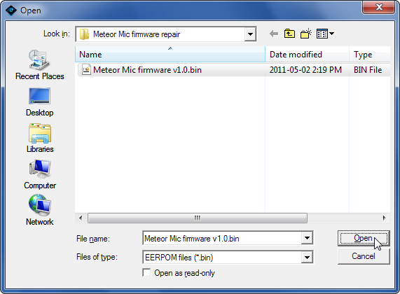
- Wait several seconds, and a window should appear that says “File -> EEPROM completely.” Press Ok and close the configuration tool.
- Unplug the Meteor Mic and re-connect it. It should now function correctly, being listed as Samson Meteor Mic and lighting the blue LED:
