Setting up Samson Controllers with FL Studio
MACKIE CONTROL
When you want to use your Samson controller to control things like volume faders, pan knobs, mute/channel select switches, transport controls and VST instruments, keep in mind you have basically two different methods to work with…Mackie Control and generic control. Mackie Control is a protocol that is hard-wired to control volume faders, pans, mute/channel select and transport controls. If you want to manipulate controls of your plug-in instruments, you’ll want to use generic assignments that you’ve made manually. Select Samson controllers support Mackie protocol where as others allow for flexible manual assignments. If your Samson controller provides a Mackie Control preset it needs to be selected for Mackie Control. The built-in Presets on the Samson Graphite 25 and 49 are specifically designed for Mackie Control.
Let’s now setup control with FL Studio:
- Within FL Studio click on Options>MIDI Settings and select the MIDI tab. You’ll see your Samson controller listed in the Output and Input section.
- Make sure you select your Samson controller in the Output menu
- Choose the first SAMSON Input option listed in the Input menu and the MIDI5 input if available. The first SAMSON input makes the connection to use keys or pads if available while the MIDI5 input connects the remote control required for your knobs, faders, transport etc. Not all controllers will offer a MIDI5 option since not all have multiple MIDI output ports. Now Click Enable (#1) to activate.
- Select Controller Type (#2) and choose Mackie Control Universal
- Go to the Ports (#3) area and choose the same port number for both Output and Input by clicking-and-dragging up/down within the area.
You should now be able to use your faders, knobs, switches and transport controls…
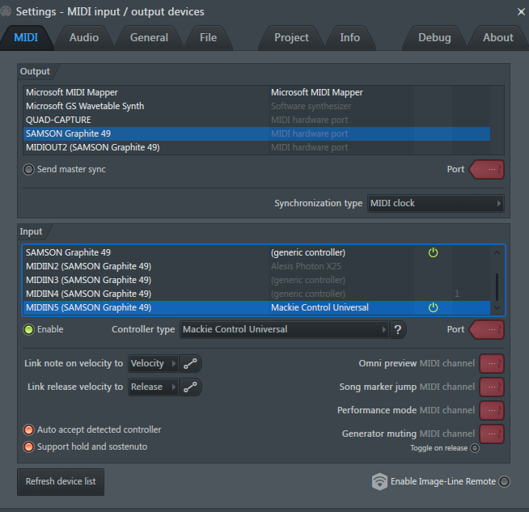
#3
#2
#111

